ERC Consolidator Grant 2013

Research proposal [Part B2)]

(not evaluated in Step 1)

Part B2: The scientific proposal

Section a. State-of-the-art and objectives
Encoded chemical libraries have been validated as an innovative way to greatly accelerate the discovery of interactions between small-molecules and biomolecules of importance such as enzymes and nucleic acids, thus becoming a technology which has attracted increasing interest from biotech and pharmaceutical companies.[1-2] These encoded strategies have been presented as a solution to screen large combinatorial libraries against biomolecules in a meaningful manner and offering a second chance to combinatorial approaches. Once, combinatorial chemistry was hailed as the future for drug discovery due to their ability of generating large number of compounds in relatively short period of time, however those great hopes were never met as they could not generate many meaningful biological data. The difficulty to screen large libraries of compounds within biological systems could not be initially overcome but encoding approaches are changing this perception. For the encoding task, DNA and Peptide Nucleic Acids (PNA) have already being used as barcode tags for a variety of applications, most notably the elegant work of David Liu in Harvard [3] and Nicolas Winssinger [4] in Strasbourg and also by myself together with Mark Bradley in Edinburgh [5]. During the past 8 years dozens of large DNA encoded small-molecules libraries have been synthesised by big institutions such as Standford, ETH Zurich and Harvard and also big pharma companies such as GSK using split-and-mix approaches, which allow synthesising a number of compounds which increase exponentially with the number of chemical steps and therefore reducing massively time and materials required. [1, 6-8] However to date it has not been possible to test the effects of encoded small molecules on cellular phenotype in a microarray format. The latest innovation in this field has presented the use of PNA encoded peptide libraries with cellular systems such lymphocytes and adherent cell lines to find peptides as selective cellular penetrating peptides [9] and integrin ligands [10], an innovation of which I have been a key part of it.
While those latest results show the feasibility of using these libraries with more complex systems it does still not resolve the issue of how release encoded small-molecules within cells to induce phenotypic changes and then unequivocally identified which small-molecules are responsible of those changes. In order to truly be considered a proper platform based on large library of compounds for accelerating drug discovery and also finding chemicals which induce cellular differentiation the previous issue has to be resolved for both suspension and adherent lines (e.g. stem cells, primary cells, suspension, cancer stem cells, circulating tumoral). This proposal presents key innovative steps to allow the use of large encoded libraries as chemical tools to create High-Throughput Cell-based Phenotypic Screening Platforms.
The key question is how to cleave small-molecule compounds from their tags and still be able to track down that small-molecule after causing a phenotypic event. ChemArrays offer two different approaches depending on cell type.
- Adherent cells. In this part, split and mix libraries having both PNA and DNA barcode tags will be synthesised on solid support, following established protocols. [1, 10] Two libraries based on triazine and adenine scaffolds will be initially prepared (see Scheme 1). The key issue will be resolved by using (i) polymeric hydrogels and (ii) tailored cleavable linkers between the small-molecules and their PNA or DNA tags. The polymers in this proposal will act not just as biocompatible supports to favoured cellular attachment but also as both catalyst to allow cleavage of the tailored linkers and micro-wells to maintain small-molecules in defined places. ChemArrays will use the features of DNA/PNA to decode the libraries. This innovation will allow assessing ‘free’ small-molecule actions and not as big conjugated with their tags, DNA or PNA, which might distorsionated the real biological effect of small-molecules. These arrays will be thus base on cell-based polymer microarrays, a technology which has been exploited mainly by Prof. Langer from MIT [12] and Prof. Bradley with myself in Edinburgh [13-14] and given rise to a broad variety of applications from finding anti-bacterial materials [12] to materials which induce phagocytosis [15], hepatic cell growing and thermo-responsible hydrogels for stem cell manipulation [16] to name just a few. ChemArrays will use the features of DNA/PNA to decode the libraries. Encoded small-molecules will be organised into a defined xy array format via perfect matching between PNA or DNA barcode tags and their complementary DNA oligomers printed onto defined 2D xy coordinates [17]. Therefore, each small-molecule will then be addressed to a specific and defined position and will be displayed in fixed positions of the surface (step 1, Figure 1). Then, hydrogels capable to favour cellular adhesion and grafted with metal catalyst to cleave the linker between tags and small-molecules will be deposited onto the array (step 2, Scheme 1). Linkers will be cleaved (step 3) and cells will be seeded and will grow on top (step 4). Stimuli-responsible hydrogels will be used in order to control the delivery of chemical entities embed in them once cells are adhered, acting as retarding delivery system. [16-18].Following immunostaining, the use of imaging systems such as high resolution scanners based on fluorescence microscopy will be used and High Content Screening (HCS) performed (step 5).[13] These systems have flexible resolutions (up to 0.2 μm) and able to use up to eight different fluorophore channels together with robotic to allow automation, essential to scan high-density arrays. Small-molecule concentrations have to be thought as local concentrations in spots so that they will be high enough to allow cells to uptake them. This approach will have the ability of creating different small-molecule formulations per position just by simply mixing DNA oligos at different positions (step 1).
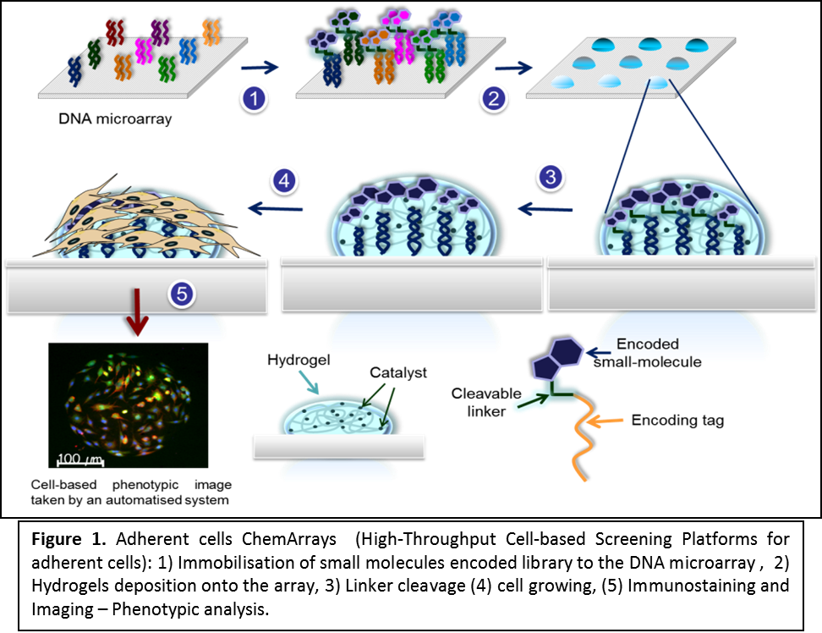
The innovative delivery of this part will be hybrid DNA-small-molecules-polymer microarrays as HT platforms for cell-based assays. This platform will become a very useful tool to develop patient-based cancer drugs helping to asses rapidly drug efficacy using primary tumoral cell lines. Its unique features, automation, multiplexing and low amount of cells required to identify small molecules that target those cell lines, especially hard to drug cell lines, such as cancer stem cells could mean a critical shift in the field of personalised medicine.
Figure 1. Adherent cells ChemArrays (High-Throughput Cell-based Screening Platforms for adherent cells): 1) Immobilisation of small molecules encoded library to the DNA microarray , 2) Hydrogels deposition onto the array, 3) Linker cleavage (4) cell growing, (5) Immunostaining and Imaging – Phenotypic analysis.

An alternative to ChemArrays could be to use high-throughput small-molecule screen by spotting on a defined array format individual compounds. This was first presented by Sabatini with a very small library of compounds [19], however to achieve that with bigger compound libraries (up to 10,000 members libraries) they would have to be synthesised in a parallel fashion. ChemArrays will carry out the synthesis of these libraries using split and mix techniques, meaning a dramatic reduction of time and material. Also, spotting small-molecules onto 2D surfaces would have issues regarding cross-contamination, when high-density arrays will have to be produced, due to the lack of any strong interaction between surfaces and molecules. Other alternatives such as pre-mixed compounds and polymers before spotting would be not achieved the desire high-throughput results, one library would have to be used with just one polymer and therefore to test just a single cell line.
Figure 1. Adherent cells ChemArrays (High-Throughput Cell-based Screening Platforms for adherent cells): 1) Immobilisation of small molecules encoded library to the DNA microarray , 2) Hydrogels deposition onto the array, 3) Linker cleavage (4) cell growing, (5) Immunostaining and Imaging – Phenotypic analysis.

This platform will be initially applied to study phenotypic changes in cancer stem cells and differentiation processes in pluripotent cell cultures (i.e., embryonic carcinoma) that can be obtained from commercial sources. Dr. Juan Antonio Marchal from the University of Granada will support the cancer stem cells application by using cancer stem cells from colon, breast and melanoma and looking at both plurypotency markers such as Oct-4, Nanog and Sox 9 and specific cancer stem cell markers such as ALDH1, CD44 and CD133. The applications regarding the generation of iPS cells from adult somatic cells will be supported by Dr. Jose Luis Perez Garcia from GENyO. A few molecules have already been identified with the ability to either improve the process of reprogrammation or replace one or two of the genes deemed necessary for reprogramming.[20] We will screen our enconded libraries looking for small molecules that can replace some of these reprogramming transcription factors.
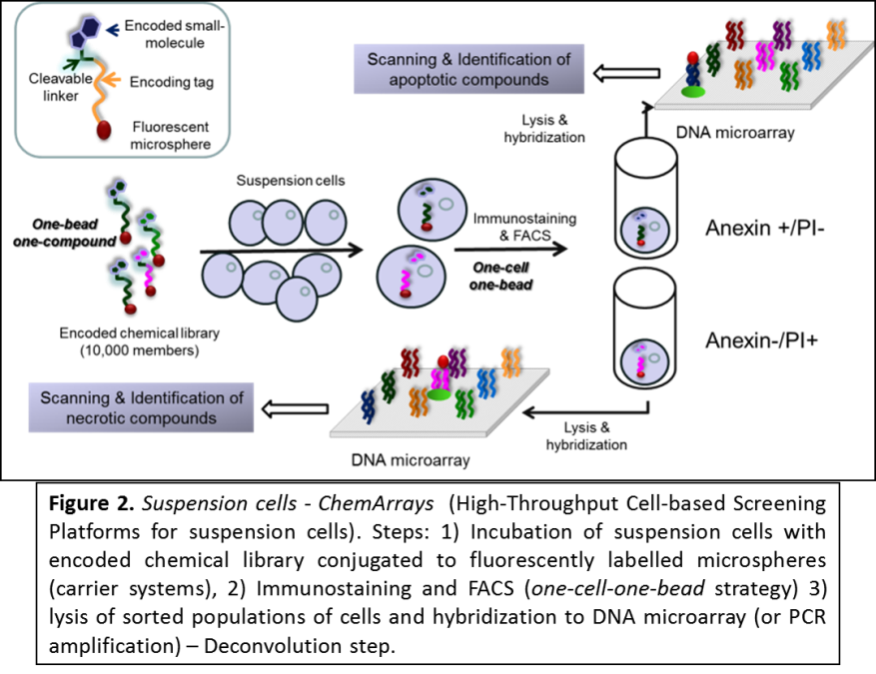
(ii) For suspension cells. In this case, a different and more challengeable approach has to be followed. A perfect assay could be named as one-bead-one-compound & one-cell-one-bead (OBOC & OCOB) as it would need to be able to obtain just one encoded small-molecule per cell to be released intracellularly. Then, following immunostainning, cells could be sorted by fluorescence-acting cell sorting (FACS) based on phenotypic changes and, at that stage, still be able to track down which small-molecules are responsible of certain phenotypic changes(see Figure 2). To meet those needs, ChemArrays proposes to encode libraries using, in this case, just PNA instead of DNA to avoid cellular nucleolytic activity and to be built on microspheres to create solid-supported libraries (Scheme 2). If compare with approach (i) libraries will be kept supported on microspheres to be used with cell cultures. ChemArrays will use polystyrene microspheres (0.1μm to 2μm) developed by Dr. Sanchez-Martin (who works at the Universidad of Granada and also is ascribed to GENyO Research Centre, as my myself, and who will support this project) and Prof. Bradley.[21] These carrier systems have been proven to be very efficient and non-toxic intracellular devices which allow also carrying out multi-step solid phase organic chemistry reactions. PS-microspheres are uptaken by cells (beadfection) in a time and size depending manner, so the technology have an intrinsic control which will allow to find conditions to have the biggest population of cells with just one microsphere. Using FACS gating, that population could then be clearly identified as PS-microspheres, labelled with a fluorophore which will be detected with an excitation and emission wavelength different than immunostainning reagents, will be used. These assays will be performed at GENyO which is equipped with last generation FACS facilities. In the chemical part, a standard split and mix approach, following solid-phase methodologies, will guarantee that one microsphere will have one compound (see Scheme 2). Both facts are essential to make sure that phenotypic changes are caused by a single chemical entity not by random events. Once, sorted out cell populations with certain phenotypic profiles, cell lysate containing microspheres linked to their PNA tags will be decoded by DNA microarray. A key consideration for this type of assays is that it will measure the impact of small-molecules just in cells which have uptaken microspheres but not in their off-spring cells. This very challenging approach will thus convert cell-based assays into big single-cell assays where thousands of different drugs are assayed against millions of different cells.
The project will deliver a highly innovative technology which will help to find new chemicals and chemical combinations as drug concktails and also as drivers of cell differentiation at a speed not seen before. This technology will also be valuable for chemical genetic screens which aim to study the impact of chemicals in cellular phenotypes therfore involving testing thousands of small molecules for their effects on cells; subsequently, the proteins targeted by these phenotype-modifying compounds are identified.
The development of such an innovative technology may provide opportunities to engage with European and multinational companies specialised in drug discovery and as well as potentially providing new market opportunities to develop new platforms to support the exploitation of the technology. ChemArrays will be also aligned with the European Partnership for Alternative Approaches to Animal Testing (EPAA) goal to develop and validate alternative strategies to animal testing. ChemArrays feature HTS capabilities, large numbers, together with an HCS output, cell-based technologies that are gathering importance as they are being seen as an efficient alternative to animal testing.
The opportunities in the medium and long term are:
• Large and financially active market which need advances in technologies to give an answer to the personalised medicine era.
• Potential for considerable licensing deals with pharmaceutical and biotechnology companies through direct agreement between those companies and either the University Knowledge Transfer Office or a spin-off created from the intellectual property generated.
• Potential to be useful as background IP to areas such as drug discovery, cell-based therapies, chemical biology, biotechnology and nanotechnology.
• Students and postdoctoral researches will gain an unique set of cross boundary skills which will make them to become strong candidates for competitive scholar and fellowships and also very attractive in the highly competitive biotechnology job market.
In the short term the project will also deliver development and innovation in the different discipline involved in this project. For instance the material chemitry area will benefit from the new findings and the new metal-decorated hydrogels created during the project which could then be used for novel applications in the field of regenerative medicine. In the case of the nanotechnology field the development of PNA- microspheres will have a direct application in the diagnostic area. Finally, it is quite likely that this platform will also be applied to study PNA and DNA mimics as therapeutic agents themselves. All these paralell applications de-risk the project as a whole.
Overall aims and objectives of the research programme.
(a) Development of a HTS methodology to analyse arrays of metal-grafted hydrogels for cellular attachment while allowing controlled release of small molecules.
(b) Synthesis of split and mix DNA and PNA-encoded libraries of small-molecules using solid phase chemistry.
(c) Spatial organization of the libraries in a 2D format using DNA microarrays, based on PNA-DNA hybridization properties
(d) Production of DNA-small molecules-polymer hybrid arrays.. This will allow cleaving of small-molecules from barcode tags while embed in the polymer spots. Polymer spots will act as mini-wells where cells will be adhered and small-molecules released.
(e) Use of hybrid arrays to carry out cell-based assays to study phenotype changes in cancer cell lines, including cancer stem cells, and differentiation process in pluripotent cell cultures (i.e., embryonic carcinoma) that can be obtained from commercial sources.
(f) Synthesis of a PNA-encoded library of small-molecules on polystyrene-microspheres.
(g) Use of the PS-microsphere supported PNA-encoded library to study phenotype changes in human immortalised myelogenous leukemia cell line K562 assisted by fluorescence-activated cell sorting (FACS)

Section b. Methodology

Microarray technology has revolutionised the study of genetic and proteomic processes speeding up screening in ways that only a few years ago would have been considered impossible or impractical. With the help of these and related technologies we are now entering one of the most exciting times in scientific discovery with the DNA sequence of the human genome and global SNP analysis being just two recent examples.2³ Microarrays have now been demonstrated to be a valid platform in a broad range of areas from genomics to biomaterial science.

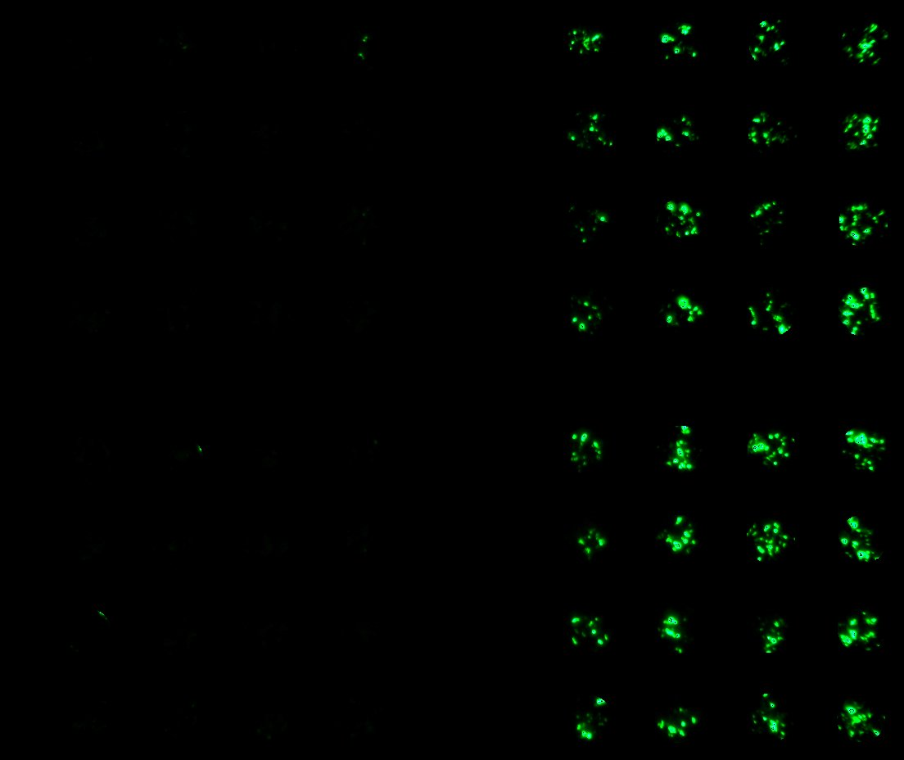PNA is a DNA mimic which has been widely used since 1991 when Nielsen et al. published on its ability to hybridize to complementary DNA sequences with even higher affinity and specificity than DNA hybridises to DNA or RNA.2⁴ This property together with its chemical and biological robustness makes it an ideal candidate to use as a localisation tag. I developed and successfully applied5 an encoding method which used PNA as a tag for peptides in order to analyse thousands of potential substrates against proteases, kinases (abl), allowing the complete interrogation of all members of the library by virtue of the 2D DNA microarray in which all the peptides were immobilised in an addressable sense. whereas we developed a new strategy to allow efficient PNA and peptide orthogonal extension. Independently, the Winssinger group has presented other applications using the same concept being the two main teams in the word which ha develop the know-how to produce PNA encoding libraries.2⁵

Cell-based micro-arrays were presented initially by Ziauddin and Sabatini who demonstrated the ability of transfecting cells with different cDNA on a microarray format. Following that up, I published the use of library of cationic lipids was printed down using gelatine as a gel-pad and pEGFP as DNA plasmid, giving rise to so-called “transfection chips” (Figure 3).³¹ The efficiency of the cationic lipids as transfection reagents was analysing by detecting GFP production using fluorescence scanning. Latter Bailey and Sabatini used known small-molecule in a similar format to carry out cell-based assays.¹⁹ These experiments prove the feasibility of screening cell systems on
Figure 3. Transfection Chip
microarray platform where every feature of the array acting as a mini-well with a different compound in each. From them cell-based microarrays have experimented a boom due to the work developed by Prof. Langer and Prof. Bradley in the field of polymer microarray. I started with Prof. Bradley this journey and it is impressive the broad range of applications that this technology is producing, including know-how and intellectual propriety which have originated a number of spin-off companies.

Having experience in all of these areas I propose the following methodology to achieve the goal of the project

(B). Methodology:

(a) Development of a HTS methodology to analyze polymer materials.

A key element of this methodology will be how to cleave the small-molecule compounds from their PNA tags, while keeping them on their positions (spatial encoding) and make them available to be tested on cellular systems. This project will resolve this issue in two ways (i) by using polymers and (ii) tailored cleavable linkers in order to keep molecules spatially localised as well as to cleave the link between the small-molecules and their PNA or DNA tags. The polymers in this proposal will act not just as inert supports but also as “artificial enzymes” to allow hydrolysis of the tailored linkers. The rational design of these macromolecules is particularly challenging. Therefore, assisted with a robotic inkjet printer in situ nanolitre-scale polymerisation will be performed.¹⁸ This methodology has already given rise to very good results as it was applied to discover novel thermo-sensible hydrogels ideal for stem cell culturing.¹⁶ Furthermore the new fabricated polymer microarrays have an ideal format to develop a more informed and better-designed polymer and to obtain lead structures. These arrays, containing more than 2,000 polymers per array, will then tested to find materials capable of:

- Cleave tailored linkers through their grafting groups.
- Promote cellular adhesion and growing (for each cell type a set of polymer microarrays will then be to be used.
- Controlled release of small molecules from them towards the cells.

Therefore:

(a). Polymers will be synthesised in-situ with a robotic inkjet printer (Scheme 3).

(b). Fluorogenic substrates on 7-amino-methylcoumarine will be incubated on the arrays to detect polymers with cleavage capability (Scheme 4).

(c). Polymer arrays will also be used to study cell compatibility. As mentioned before, polymers will act as inert support to allow cellular adhesion.30 Cell-based polymer microarray applications have exploded in the past 5 decade producing high quality results. (Figure 4). Determination of cell compatibility will be a key factor in this methodology in order to use polymer spots as mini-wells.
Scheme 4. HTS of polymer materials to identify polymers capable to cleave tailor linker and also to control release of small molecule. Scheme based on 7-amino-methylcoumarin cleavable capability.
Scheme 3. Robotic inkjet printer for in situ nanolitre-scale polymerisation (Chem. Commun. 2008, 1317-1319
(d). Diffusion of small-molecules within polymer spots will be optimised. Fluorescently labelled representative members of libraries will be used to carry out these studies. Polymers will have to delivery chemical entities embed in them once cells are adhered, acting as retarding delivery system.

Figure 4. Cell-based assay using polymer arrays.³²

Having in hand the results of the previous screen libraries will be synthesised using as a linker the chemical functionality identified above. Figure 5 shows the final structure of a PNA-encoded small molecule library.

Figure 5 General structure of PNA-encoded small-molecule libraries. Cleavable linker will be based on ester or disulfide bonds to facilitate the action of polymers as artificial enzymes.

(b). Synthesis of split and mix PNA-encoded libraries of small-molecules.

The synthesis will be carried out using solid phase synthesis both in parallel but also following split and mix principles. Briefly, split and mix approaches can generate a very large number of compounds which is exponential to the number of synthetic steps, therefore the number of synthetic steps grow linearly while the number of compounds generated does it exponentially. Small-molecule cores will be designed in order to give structural diversity to the libraries. Briefly, every building block will be encoded by a unique PNA unit (triplet or quadruplet, depending on the number of building blocks used). The chemistry used to build up the PNA sequence and the small-molecule compound arms will need to be fully compatible. PNA is a very robust chemical structure and there is a broad range of protecting groups this should not be a major problem. I developed new set of PNA protected monomers (Dde/Mmt) which give much more orthogonality with other chemistries33 but other chemistries (Fmoc/Bhoc – Mmt/Boc) will be also explored.4

The encoding process with PNA will be achieved as I have previously published,^{33,5} thus following the addition of a building block an encoding PNA unit (monomer by monomer) will be attached in a stepwise manner before mixing and splitting. However a more elegant strategy which will be developed where PNA encoding triplets or quadruplets will be presynthesised by SPS and used as single building blocks during the synthesis of the libraries (Figure 6). This alternative will speed up the synthesis of the libraries and facilitate the increased robustness of the whole synthetic process.

Figure 6. Triplet Formation for Pre-Tag Synthesis.

The first library will be based on the triazine core which has been shown to have important biological activities. Triazines have a 3-fold symmetry and three positions of attachment to the core allowing versatile modifications. Moreover, the differential reactivity of tri-, di- and monochloro triazines allows the randomization of all three positions by solid-phase synthesis (Scheme 5) 20 building blocks will be used requiring PNA quadruplets (the final size of the library will be 20x20x20=8,000). As initial proof of concept it is proposed to synthesise this library following the protocol presented by GSK and Praecis.¹ This library has been used to study Aurora A kinase and p38 MAP kinase the synthetic pathway described in Scheme 1. In this Objective and as initial proof of concept, this project will target to encode a modest 8,000 members with both DNA and also PNA. The rationale behind it is to compare which tag performs better in the DNA-small molecule-hydrogel microarray format.

Scheme 5. Triazine-based librarie. 20 building blocks will be used

A key element which will need to be optimised is the tailored linker which has to be designed accordingly to the modified hydrogels used in objective c). Initially, ChemArrays propose the use of an azide immolative linker that in conjunction with ruthenium complexes is reduced and consequently cleaved via Staudinger reaction upon irradiation at 455nm (see Scheme 6), realising small molecules from their tags.¹¹ Alternatively, phosphine modified hydrogels instead of ruthenium could be also tested.
Scheme 5. Immolative linker

Other scaffolds will be based on heterocylces due to their well-known activities as inhibitors of important enzymes or receptors involved in essential cellular functions, for instance kinases or adenosinic receptors. These heterocylces present chemical functions which allow structural modifications of their cores. Therefore, pyrimidines, purines, dihydropyridines, tricycles trycicles nonxanthines indoles, benzodiazepine and quinoxalines might be chosen (Figure 6). Each scaffold will have three randomised positions which will be derivatised using twenty different building blocks (20x20x20; 8,000 different compounds per scaffold) These scaffolds will be used from halogen derivatives allowing further substitutions with compatible chemistries such as Suzuki coupling, aromatic substitution nucleophilic, acylacion and quaternization. A big advantage of using solid-phase chemistry, if compared with solution phase, is the possibility of forcing reaction conditions through molar excess of some of the reagents.
Figure 6. Scaffold which will be used
An example of synthesis of a purine derivative library is shown in Scheme 8.

Scheme 8. Synthesis of purine library. PNA triplets will encode every randomise position.

(c) Spatial organization of the libraries in a 2D format using DNA microarrays.
DNA microarray DNA-PNA microarray
Figure 7. Spatial organization of PNA-encoded libraries onto a 2D DNA microarrays. Also applicable to DNA codes.
The PNA code will allow the organisation of large libraries of compounds. The current benchmark of customised DNA oligonucleotides is over 44,000 features in a spatially defined manner through immobilisation onto a 2D DNA array (following Watson-Crick base paring rules) (Figure 7). Although covalent immobilization of compounds onto microarrays has been carried out previously, and is an elegant and successful approach to study protein-protein interactions, enzymatic activities or cellular adhesion in a HT manner, it has major limitations in that does not allow the analysis of phenotype changes induced by molecules through protein modification or alteration as well as requiring the synthesis of compounds in a parallel manner, a major undertaking when looking at large number of compounds. However, this platform will be used as an immobilisation approach to carry out: (i) cell adhesion studies. These studies will be important to know how to module integrins and (ii) studies of interactions between proteins and small-molecules This method has a major advantage if compared with those currently available due to the fact that the synthesis of the libraries can be carried out using a combinatorial approach and not in parallel meaning a dramatically reduction of time and materials

(d) Production of DNA-polymer hybrid arrays

Split and mix libraries of small-molecules bearing every member of the library will be hybridised onto the DNA arrays using complementary oligomers to the encoding PNA and or DNA (Fig. 3). Therefore, every member of the library will occupy a unique and spatially defined place on the 2D array. Then, polymers identified in the previous screening will be spotted either on top of every position in the array or across the whole array thereby allowing the cleavage of all the array elements and their defined embedding in the polymer substrate. The former approach will be achieved using inkjet microarraying technology that has been used to synthesise large number of unique DNA oligomers on glass slides proving the high resolution of these robots. Currently, high density DNA oligonucleotides commercialised by Agilent and OGT use a coating mask to create a very hydrophobic surface with hydrophilic islands which is where oligonucleotides are synthesised. This will help to spot hydrogels on top of DNA microarrays with a Scienion inkjet printer in a fully automatic manner.

(e) Cell-based assays using DNA-polymer arrays

Once compounds have been released, microarrays will be incubated with cell cultures, allowing the screening of 10,000 different compounds in a single experiment with different cells lines (Scheme 3). This will allow the assaying of not “just” 10,000 compounds at once but also on a variety of different cell types. Phenotypic changes induced by small-molecules will be studied by a variety of well-established methods for cellular investigation, such as immunoassays and image analysis with examination of the arrays carried out by fluorescence scanning and microscopy.
Briefly, when cells are modified giving rise to phenotypic changes its immunology is altered producing specific antigens. Detection of these antigens by labelled antibodies has been largely used in cellular investigations. This project will extrapolate these methods to cell-based microarrays. Similar things can be said regarding pluripotent cells, well-known methods are able to detect cell differentiation and therefore, this platform will be used stem cells in order to study differentiation induced by small-molecules.

Scheme 9. Production and application of DNA-polymer hybrid arrays on cellular systems

Applications:
(i) Cell-based phenotype assays (Scheme 9). Histones are proteins which are highly linked to differentiation and cell cycle progression in mammalian cells lines. They are regulated by acetylation/deacetylation, its acetylated form the one which provokes cell cycle arrest. These processes are regulated, mainly, by two enzymes histone deacetylase (HDAC) and histone acetyltransferase (HTA) and has been demonstrated that they can be modulated by small-molecules. The alteration of this pathway leads to phenotype changes which can be detected by established cellular methods. Therefore, microarrays containing compounds embed in polymer matrix will be analysed as potential HDAC or HTA inhibitors using fluorescence and microscope meanings. Adherent tumoral cell lines, such a B16F10 and cancer stem cells from commercial sources will be used.

(ii) Cellular differentiation and dedifferentiation studies of pluripotent cells (i.e., embryonic carcinoma) that can be obtained from commercial sources and lineage cells respectively. This platform will be used to induce differentiation and even a more exciting idea dedifferentiation on mammalian cells. This will help to discover mechanisms and signalling pathways involve in these processes. Indirect ELISA assays using primary antibodies such as anti-cytokeratin 7 or mouse anti-myogenin will be used in order to detect differentiation processes.
(f) Synthesis of a PNA-encoded library of small-molecules on polystyrene-microspheres.

In a very similar manner than in Objective (b), the synthesis of libraries will be done using split and mix methods in order to secure that there will be one compound per bead. But in this case, compounds will permanently be attached to microspheres to be then carried into the cells. The general structure of the triazine library supported on microspheres is shown in Figure 8. Following protocol developed by Dr, Sanchez- Martin we will prepared fluorescently labelled microspheres and they will be used. In this case the linker will have to be cleaved intracellularly by some of the elements of the cellular machinery. Therefore it is forecast to use disulphide and peptides (that will be specifically cleavage by intracellular enzymes) to act as linkers.
Figure 8. General Structure of microsphere-supported PNA encoded library

(g) Use of the PS-microsphere supported PNA-encoded library to study phenotype changes in human immortalised myelogenous leukemia cell line K562 assisted by fluorescence-activated cell sorting (FACS)
Following incubation of the cell model, K562 cells, with the PNA-encoded library attached to the fluorescently labelled microspheres, they will be evaluated by flow cytometry. Different parameters such as concentration and incubation time will be studied. In the first stage of the analysis, the cells will be gated based on the number of beads internalised by cells. Recently, we have observed (unpublished results that by tuning the right size ( 1.5-2 um ) of the fluorescent microspheres it is possible to gate different populations of cells depending on size. Consequently, the population of cell corresponding to one bead/one cell will be gated. This gated population will be interrogate against an specific biological event. In particular we will evaluated the cell viability/ apoptosis using Annexin/PI immunostaining. Then, populations for the assay will be sorted by FACS (FACS Aria is available at GENyO). Sorted populations will be lysated and the probe will be deconvolutated by DNA microarray or PCR amplification.

References :
- Clark, M.A. et al, Nat. Chem. Biol., 2009, 5, 647-654.
- Kleiner, R.E., Dumelin, C.E., Liu, D. R., Chem. Soc. Rev., 2011, 40, 5707-5717.
- Chen, Y., Kamlet, A. S., Steinman, J.B., Liu, D. R., Nature Chemistry, 2011, 3, 146-153.
- Chouikhi, D., Ciobanu, M., Zambaldo, C., Duplan, V., Barluenga, S., Winssinger, N., Chem. Eur. J., 2012, 18 (40), 12698-12704.
- Diaz-Mochon, J.J.; Bialy, L. Keinicke, L. and Bradley, M. Combinatorial Libraries-From Solution Assays to 2D Microarray. Chem Commun 2005, 1384. Pouchain, D., Díaz-Mochón, J.J., Bialy, L., Bradley, M., ACS Chem. Biol., 2007, 2 (12), 810-818.
- Buller, F. et al, ACS Chem. Biol., 2011, 6, 336-344.
- Kleiner, R.A., Dumelin, C.E., Tiu, G.C., Sakurai, K., Liu, D.R., J. Am. Chem. Soc., 2010, 132, 11779-11791.
- Heng, H. et al, J. Med.Chem., 2012, 55, 7061-7079.
- Svensen, N.; Diaz-Mochon, J. J.; Dhaliwal, K.; Planonth, S.; Dewar, M.; Armstrong, J.D.; Bradley, M. , Angew. Chem. Int. Ed., 2011, 50(27), 6133-6136.
- Svensen, N.; Diaz-Mochon, J. J.; Bradley, M., Chem. Biol., 2011, 18, 1284-1289.
- Röthlingshöfer, M., Gorska, K., Winssinger, N., Org. Lett., 2012, 14 (2), 482-485.
- Hook, A.L. et al., Nat. Biotech., 2012, 30 (9), 868-875.
- Pernagallo, S.; Diaz-Mochon, J. J.; Bradley, M., Lab on a Chip, 2009, 9, 397-403.
- Pernagallo, S. et al., Advanced Healthcare Materials, 2012, 1(5), 646-656.
- Mant,A., Tourniaire, G., Diaz-Mochon, J.J., Elliott, T.J., Williams, A.P., Bradley, M., Biomaterials, 2006, 27(30), 5299-5306.
- Zhang, R., et al., Nat. Comm., 2013, 4(30), 1335 (doi:10.1038/ncomms2341).
- Diaz-Mochon, J.J.; Bialy, L., Bradley, M., Chem. Comm., 2006, 38, 3984-3986.
- Zhang, R., Liberski, A., Khan, F., Diaz-Mochon, J.J.; Bradley, M., Chemical Communications, 2008, 11, 1317-1319.
- Bailey, S.N., Sabatini, D.M., Stockwell, B.R. , PNAS, 2004, 101, 16144-16149.
- Desponts C, Ding S., Methods Mol. Biol., 2010, 636, 207-218.
- (a) Unciti-Broceta, A.; Díaz-Mochón, J. J.; Sánchez-Martín, R. M.* and Bradley, M.* Accounts of Chemical Research, 2012, 45(7), 1140-1152. (b) Yusop, M.; Unciti-Broceta, A.; Johansson, E. M.V.; Sánchez-Martín, R. M.; Bradley. M., Nature Chem., 2011, 3, 239-243.
- Svensen, N.; Diaz-Mochon, J. J.; Bradley, M., PLoS ONE, 2011, 6(9), e24906
- D. D. Shoemaker et al. Nature, 2001, 409, 922 – 927; Venter, J.C. et al. Science, 2001, 291, 1304-51 Nature, 2001, 409, 860-921
- Nielsen, P.E. Egholm, M., Berg, R.H., and Buchardt, O. Sequence-Selective Recognition of DNA by Strand Displacement with a Thymine Substitutes Polyamide, Science, 1991, 254, 1497
- Winssinger N, Damoiseaux R, Tully DC, Geierstanger BH, Burdick K, Harris JL. Chemistry&Biology, 2004, 11(10), 1351;
- Langer R, Tirrell DA, Nature, 2004, 428, 487-492
- Díaz-Mochón, J.J., Bialy, L. and Bradley. 2004, 6, 1127-1129
- MacBeath G and Schreiber SL Science, 2000, 289, 1760-1763
- Hughes TR, et al.Expression profiling using microarrays fabricated by an ink-jet oligonucleotide synthesizer. Nat. Biotechnol 2001, 19, 342-347
- Anderson DG, Levenberg S, Langer R, Nat. Biotech., 2004, 22, 863
- How, S.E.; Yingyongnarongkul B, Fara, M.A., Díaz-Mochón, J.J.; Mitoo, S. and Bradley, M. Combinatorial Chemistry and High Thoughput Screening, 2004, 7, 423-430
- Pernagallo, S. ; Unciti-Broceta, A. ; Diaz-Mochon, J.J ; Bradley, M. Biomedical Materials, 2008, 3, p. 034112
- Díaz-Mochón, J.J., Bialy, L. and Bradley. Org. Lett. 2004, 6, 1127-1129
- Thielbeer, F.; Chankeshwara, S.V.; Bradley, M. Biomacromolecules, 2011, 12, 4386–4391

Section c. Resources (incl. project costs)

(Note: To facilitate the assessment of resources by the panels, the use of the following costing table is strongly suggested.)

 | Cost Category | Month 1-18 | Month 19-36 | Month 37-54 | Month 55-60 | Total
 |  |  |  |  |  | (M1-60)
Direct Costs:

 | Personnel:
 | PI[1] | € 41,300 | € 41,300 | € 41,300 | € 41,300 | € 165,200
 | Senior Staff
 | Post docs | € 97,430 | € 97,430 | € 97,430 | € 48,715 | € 341,005
 | Students | € 31,664 | € 31,664 | € 63,328 | € 31,664 | € 158,320
 | Other | € 8,119 | € 24,357 | € 24,357 | € 24,357 | € 81,190
 | Total Personnel: | € 129,798 | € 194,751 | € 226,415 | € 146,036 | € 745,715
 | Other Direct Costs:
 | Equipment | € 160,000 |  |  |  | € 160,000
 | Consumables | € 42,000 | € 36,000 | € 36,000 | € 36,000 | € 150,000
 | Travel | € 2,500 | € 3,750 | € 5,500 | € 6,750 | € 18,500
 | Publications, etc | € 1,000 | € 3,000 | € 3,000 | € 3,000 | € 10,000
 | Other |  | € 2,500 | € 2,500 | € 5,000 | € 10,000
 | Total Other Direct Costs: | € 205,500 | € 45,250 | € 47,000 | € 50,750 | € 348,500
 | Total Direct Costs: | € 335,298 | € 240,001 | € 273,415 | € 196,786 | € 1,094,215
Indirect Costs (overheads): | Max 20% of Direct Costs | € 67,060 | € 48,000 | € 54,683 | € 39,357 | € 218,843
Subcontracting Costs: | (No overheads) | € - | € - | € 50,000 | € 50,000 | € 100,000
Total Costs of project: | (by reporting period and total) |  |  |  |  | € 1,413,058
Requested Grant | (by reporting period and total) |  |  |  |  | € 1,367,343

For the above cost table, please indicate the % of working time the PI dedicates to the project over the period of the grant: | 60 %

I will dedicate a 60% of my time over the 5 years period. The remaining 40% will be dedicated to run other funded national projects, keeping working with my international network to bring opportunities to Spain and also I have teaching duties within the University of Granada. I am confident that with the proposed team of people I could manage the project efficiently. The management of the project, which I will divided in four main sections, justify the personal requested: two PDRA across the 5 years project, a total of two PhD students in 5 years and a molecular and cellular biology technician who will start after the first 12 month of the project. My own contribution would be to support and integrate all of these areas to create an efficient interdisciplinary communication.

(i) Synthetic part. A PDRA and a student will be in charge of tackling the synthetic challenges presented in the project. Therefore, synthesis of PNA-encoding building blocks (Fig. 3) and the set of PNA monomers required achieving it, synthesis of fluorogenic-based substrates necessary to carry out HTS of polymer material, synthesis of DNA or PNA-encoded libraries of small-molecule compounds and also their microspheres supported versions will need to be addressed. In this area ChemArrays will be supported by Prof. Sanchez-Martin

(ii) Microarray technology. A PDRA with skills in the field of biotechnology will take control of this part. This part will start following protocols established previously by myself in the group in order to produce DNA and polymer arrays independently. The first objective will be the development of the methodology for the screening of polymers to find an ideal substrate for the platform. Then, printing of polymers on DNA arrays using a Scienion Inkjet printer. This part will include the development of cell-based microarray assays. Future collaborations will be looked in order to expand the platform as much as possible

(iii) Cell-based assays. The PDRA identified in point (ii) supported by the technician will work on establishing initial protocols and liaise with our local collaborators, Dr. Marchal, Dr. García Perez and Dr. Molina and also European one as Prof. Bradley from Edinburgh and Prof. Purrello from Catania. Prof. Sanchez-Martin will support the cell-based assays by FCAS.

(iv) Bioinformatics. The project will have a bioinformatics area which will be in charge of microarray designs and management of the data generated. Data management and analysis will be outsourced to companies which offer these services. Currently, the capital expenditure required to handle this is not worth as there are companies which have started to offer these services such as Ilika plc.

The facilities required to carry on this project and asked for are:

(i) Automated synthesizer to accelerate the synthesis of the encoded libraries. It has been identified Syro Wave™ Automated Microwave and Parallel Peptide Synthesizer from Biotage as an excellent candidate. Its current cost is around 90,000€
(ii) Robotic Inkjet printer, these equipments are becoming very common within the scientific community and combine the very high xy accuracy with piezo-electric nozzles to deliver nano-picoL solutions per positions. It does allow the use of both organic as well as aqueous solutions. The identified printer in Scienion S1 which cost is around 30,000€
(iii) HPLC system from either Waters or Agilent would help to speed up product characterization. On of these systems costs around 40,000€

The rest of services which are required to run the project such as FACS, fluorescence microscopy and cell culture facilities are found with GENyO the place where I will develop this project.

Consumables costs:
To carry out microarray projects the consumables required are principally: glass slides (gold or hydrogel slides), sets of pins (solid, Stealth) and piezo-electric nozzles, well-plates, incubation chambers, etc... Microarray technology is directly associated to fluorescence scanning which require the use of filters, lamps and high capacity networked data storage. Providing a good computer network within the team will allow efficient sharing of data and therefore increase efficiency.

In order to develop custom DNA arrays purchasing them from OGT or Agilent would be the preferable option at a cost of 400€ per array. For this at the early stage, home-made DNA microarrays will be also produced by ChemArrays team.
Synthetic chemistry will play a very important role in this project. The synthesis of PNA monomer sets, PNA encoding units and polymers will be carried out, requiring solvents, reagents and analysis using NMR, MALDI-TOF, HPLC, IR and GPC. Finally, cell cultures will be carried out and hence expenses generated from the Biolab will need to be covered (media, Petri dishes, micropipettes, etc). Cell screening will be carried out using fluorescence scanning and microscopy, requiring a fluorescence based-microscope (4 objetives) controlled by Leica FW4000 software.

The rest of the costs are related to travel and publications which are essential to disseminate our findings and communicate with the public our activities and also patent costs as I foresee that intellectual property generated during this project will be worth protecting it, starting with Spanish patent protection and after getting into PCT costs.

Section d. Ethical and security-sensitive issues

ETHICS ISSUES TABLE

Areas Excluded From Funding Under FP7 (Art. 6)

(i) Research activity aiming at human cloning for reproductive purposes;

(ii) Research activity intended to modify the genetic heritage of human beings which could make such changes heritable (Research relating to cancer treatment of the gonads can be financed);

(iii) Research activities intended to create human embryos solely for the purpose of research or for the purpose of stem cell procurement, including by means of somatic cell nuclear transfer;

All FP7 funded research shall comply with the relevant national, EU and international ethics-related rules and professional codes of conduct. Where necessary, the beneficiary(ies) shall provide the responsible Commission services with a written confirmation that it has received (a) favourable opinion(s) of the relevant ethics committee(s) and, if applicable, the regulatory approval(s) of the competent national or local authority(ies) in the country in which the research is to be carried out, before beginning any Commission approved research requiring such opinions or approvals. The copy of the official approval from the relevant national or local ethics committees must also be provided to the responsible Commission services.

Guidance notes on informed consent, dual use, animal welfare, data protection and cooperation with non-EU countries are available at: http://cordis.europa.eu/fp7/ethics_en.html#ethics_sd

For real time updated information on Animal welfare also see: http://ec.europa.eu/environment/chemicals/lab_animals/home_en.htm
For real time updated information on Data Protection also see: http://ec.europa.eu/justice/data-protection/index_en.htm

 | Research on Human Embryo/ Foetus | YES | Page
 | Does the proposed research involve human Embryos?
 | Does the proposed research involve human Foetal Tissues/ Cells?
 | Does the proposed research involve human Embryonic Stem Cells (hESCs)?
 | Does the proposed research on human Embryonic Stem Cells involve cells in culture?
 | Does the proposed research on Human Embryonic Stem Cells involve the derivation of cells from Embryos?
 | I CONFIRM THAT NONE OF THE ABOVE ISSUES APPLY TO MY PROPOSAL | x

 | Research on Humans | YES | Page
 | Does the proposed research involve children?
 | Does the proposed research involve patients?
 | Does the proposed research involve persons not able to give consent?
 | Does the proposed research involve adult healthy volunteers?
 | Does the proposed research involve Human genetic material?
 | Does the proposed research involve Human biological samples?
 | Does the proposed research involve Human data collection?
 | I CONFIRM THAT NONE OF THE ABOVE ISSUES APPLY TO MY PROPOSAL | x

 | Privacy | YES | Page
 | Does the proposed research involve processing of genetic information or personal data (e.g. health, sexual lifestyle, ethnicity, political opinion, religious or philosophical conviction)?
 | Does the proposed research involve tracking the location or observation of people?
 | I CONFIRM THAT NONE OF THE ABOVE ISSUES APPLY TO MY PROPOSAL | x

 | Research on Animals | YES | Page
 | Does the proposed research involve research on animals?
 | Are those animals transgenic small laboratory animals?
 | Are those animals transgenic farm animals?
 | Are those animals non-human primates?
 | Are those animals cloned farm animals?
 | I CONFIRM THAT NONE OF THE ABOVE ISSUES APPLY TO MY PROPOSAL | x

 | Research Involving non-EU Countries (ICPC Countries) | YES | Page
 | Is the proposed research (or parts of it) going to take place in one or more of the ICPC Countries?
Is any material used in the research (e.g. personal data, animal and/or human tissue samples, genetic material, live animals, etc) :
a) Collected and processed in any of the ICPC countries?
 | b) Exported to any other country (including ICPC and EU Member States)?
 | I CONFIRM THAT NONE OF THE ABOVE ISSUES APPLY TO MY PROPOSAL | x

 | Dual Use | YES | Page
 | Research having direct military use
 | Research having the potential for terrorist abuse
 | I CONFIRM THAT NONE OF THE ABOVE ISSUES APPLY TO MY PROPOSAL | x

If any of the above issues apply to your proposal, you are required to complete and upload the 'B2_Ethical Issues Annex' (template provided).

Without this Annex, your application cannot be properly evaluated and even if successful the granting process will not proceed.

Please see the Guide for Applicants for the Consolidator Grant 2013 Call for further details and CORDIS http://cordis.europa.eu/fp7/ethics_en.html for further information on how to deal with Ethical Issues in your proposal.

Adapt to actual project duration.
Please indicate here the page number of Part B2 of your proposal on which the ethical issue in question arises.
In accordance with Article 12(1) of the Rules for Participation in FP7, ‘International Cooperation Partner Country (ICPC) means a third country which the Commission classifies as a low-income (L), lower-middle-income (LM) or upper-middle-income (UM) country. Countries associated to the Seventh EC Framework Programme do not qualify as ICP Countries and therefore do not appear in this list.

